Team Project 02 - Proposal

Team Members
Trey Holthe
Andrew Ingle
Jeff Maxwell
Reagan Meagher

This Training and Incident Tracker Mobile application will have the following features:
- Allow users to search and browse training material.
- Get detail on a specific training topic
- Report incidents and see a list of past incidents reported
- Take a photo or upload a photo of the incident
- Web site for management of the training material and who has viewed what training.

Training

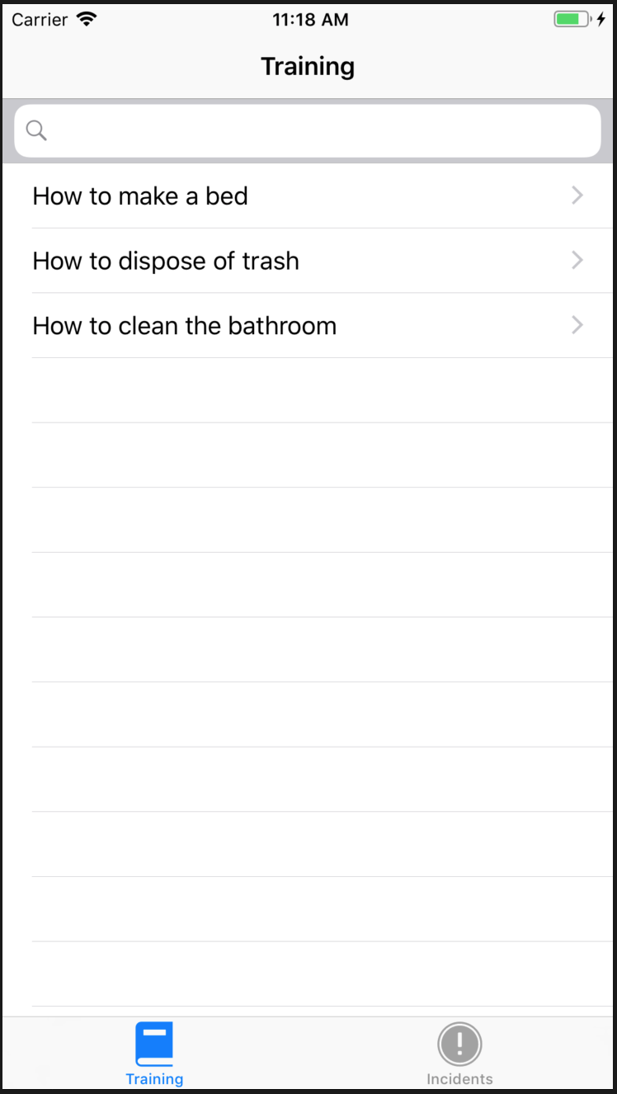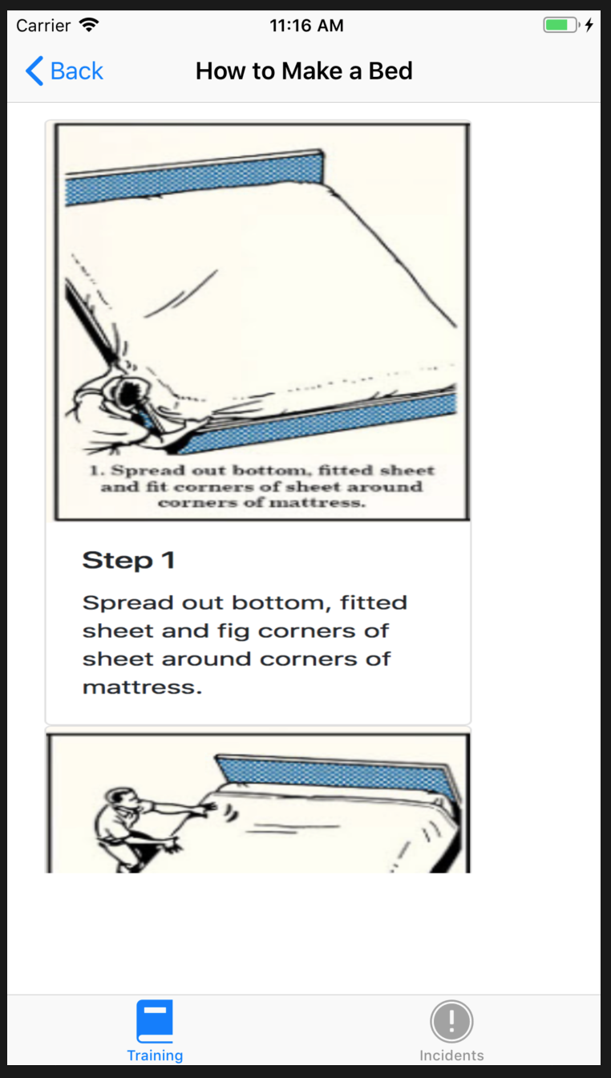

Users will see a list of all possible training material that is searchable. Once they select a specific training topic a page will be displayed with that training material. The individual training topics will be hosted web pages to the owners of the training material can add/update the training material as needed.

Incidents
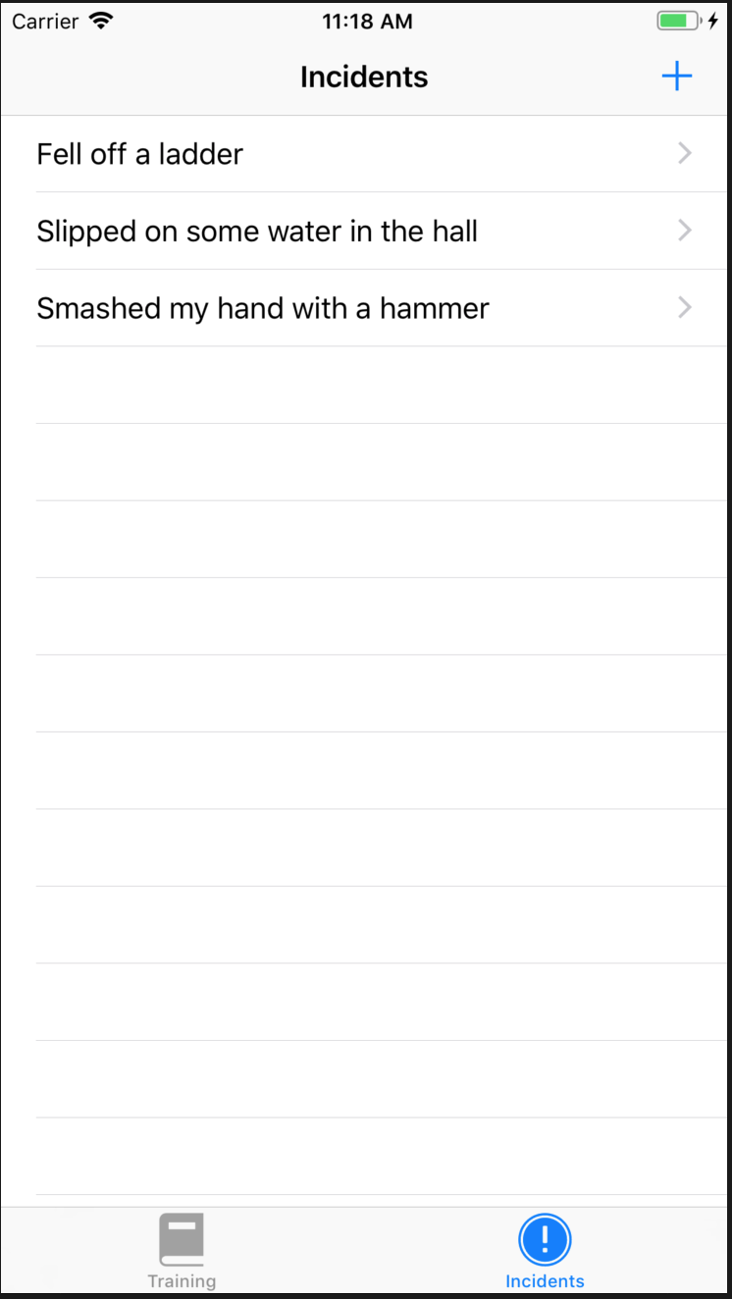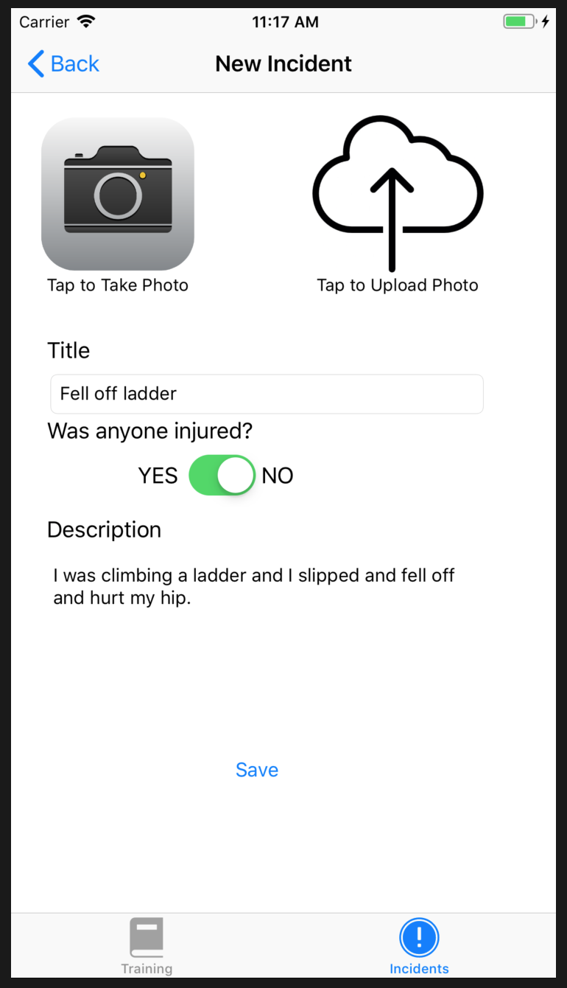

Users will see a list of previously reported incidents and be able to view previously posted incidents. They will also be able to add a new incident which includes Title, Injury Question, Description and the ability to take a photo or upload a photo associated with the incident.

If a Manager uses the application they will see incidents from multiple workers and when they create an incident they will be able to select from a list of workers.

